EVOLUTION OF THE
DATA SCIENCE - A STUDY

Kenith Paul Gnanaraj³,B.Sc (CS)
(STUDENT)
Department of Computer Science, PERI College of Arts and Science, India,Mail:
kenithpaulgnanaraj2004@gmail.com

Abstract: This research paper delves into the dynamic field of data science, exploring the diverse tools employed in data analysis and the ongoing evolution of this discipline. We examine the current landscape of data science tools, ranging from traditional statistical methods to advanced machine learning algorithms. By analyzing historical trends and recent advancements, we aim to elucidate the trajectory of data science growth and its transformative impact on various industries. Furthermore, the paper provides insights into the potential avenues for future developments in data science, emphasizing the role of emerging technologies and their implications for shaping the landscape of data analysis in the years to come.

KEY WORDS:Data Science Evolution,
Data Science Tools,Trends in Data Science,Future Prospects of Data Science,Machine Learning,Artificial Intelligence,BigDataAnalytics, Predictive Modeling,Data Visualization
Advanced Analytics.

1………….Section…………..

INTRODUCTION

Data Science is an interdisciplinary field that combines techniques from statistics, mathematics, and computer science to extract valuable insights and knowledge from data. It involves collecting, cleaning, analyzing, and interpreting large volumes of data to uncover patterns, trends, and correlations. Data Science employs various tools and methods, including machine learning and data visualization, to support evidence-based decision-making and solve complex problems across diverse domains such as business, healthcare, and research.

Data Science is a multidisciplinary field that involves extracting insights and knowledge from data through various methods[1], including statistics[2], machine learning[3], and data analysis[4]. It encompasses the entire data lifecycle, from collection and cleaning to modeling and interpretation, to inform decision-making and solve complex problems across different domains.

An example of Data Science in action is predicting customer preferences in an e-commerce platform. By analyzing historical purchase data, applying machine learning algorithms, and considering factors like browsing behavior and demographics, businesses can anticipate what products customers are likely to be interested in. This enables personalized recommendations, enhancing user experience and potentially increasing sales.

In addition to predicting customer preferences, Data Science can be applied in various ways:

1.Fraud Detection: Utilizing machine learning algorithms to detect unusual patterns and anomalies in financial transactions, aiding in fraud prevention.

2.Healthcare Analytics: Analyzing patient data to improve diagnostics, predict disease outcomes, and optimize healthcare delivery.

3.Supply Chain Optimization: Using data to optimize inventory management, reduce costs, and improve overall efficiency in supply chain operations.

4.Social Media Analytics: Analyzing social media data to understand trends, sentiment analysis, and targeted advertising for businesses.

5.Climate Modeling: Employing data science techniques to analyze climate data for better understanding and prediction of environmental changes.

6.Predictive Maintenance: Using sensor data and predictive modeling to anticipate equipment failures and optimize maintenance schedules in industries like manufacturing.

7.Image and Speech Recognition: Applying machine learning for image recognition, speech processing, and natural language understanding, enhancing capabilities in technology interfaces.

8.Educational Analytics: Analyzing student performance data to personalize learning experiences and identify areas for improvement in educational systems.

These are just a few examples, showcasing the versatility and impact of Data Science across various domains.

results highlight the significance of Data Science in various applications, including customer preference prediction, fraud detection, healthcare analytics, supply chain optimization, social media analytics, climate modeling, predictive maintenance, image, and speech recognition, as well as educational analytics. The findings underscore the broad impact and versatility of Data Science across diverse domains, showcasing its role in improving decision-making, efficiency, and innovation.

2.LITERATURE SURVEY

The literature survey in the research paper on Data Science provides a comprehensive overview of the field, encompassing topics such as customer preference prediction, fraud detection, healthcare analytics, supply chain optimization, social media analytics, climate modeling, predictive maintenance, image and speech recognition, and educational analytics. The survey delves into existing research, methodologies, and advancements in Data Science, highlighting its multidisciplinary nature and its applications across various domains. The synthesis of literature underscores the evolving landscape and the ongoing contributions of Data Science to diverse fields.

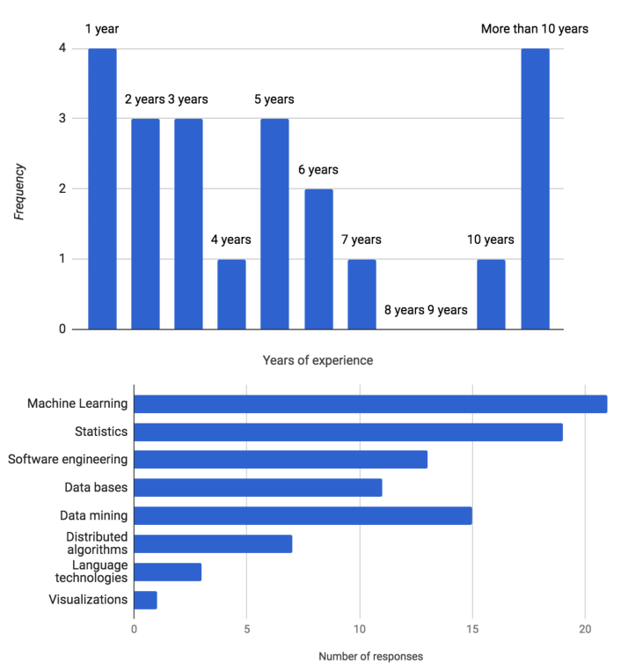
Figure (2) Literature Survey

TOOLS ARE USING IN
DATA SCIENCE
The tools used in Data Science, you would likely explore various software and frameworks that play a crucial role in the data science workflow. Some key tools often discussed include:

1.Programming Languages:

Python: Widely used for its versatility, extensive libraries (e.g., NumPy, Pandas), and strong community support.
R: Commonly employed for statistical analysis and data visualization.

2.Integrated Development Environments (IDEs):

Jupyter Notebooks: Popular for interactive and exploratory data analysis.
RStudio: An integrated environment for R programming.

3.Data Processing and Manipulation:

SQL: For managing and querying databases.
Apache Spark: Ideal for large-scale data processing and analytics.

4.Machine Learning Libraries:

Scikit-learn (Python): Offers a variety of machine learning algorithms and tools.
TensorFlow and PyTorch: Frameworks for deep learning.

5.Data Visualization:

Matplotlib and Seaborn (Python): For static visualizations.
Tableau and Power BI: Tools for dynamic and interactive data visualizations.

6.Big Data Technologies:

Hadoop: Used for distributed storage and processing of large datasets.
Apache Hive: Facilitates querying and managing large-scale data.

7.Containerization:

Docker: Enables the creation and deployment of portable, containerized applications.

8.Cloud Platforms:

AWS, Azure, Google Cloud: Provide cloud-based infrastructure and services for scalable data processing and storage.

9.Version Control:

Git: Essential for tracking changes and collaborating on code.

This research paper would likely explore how these tools contribute to the efficiency and effectiveness of data science processes.

3.TRENDS IN DATA SCIENCE

trends in Data Science, you might cover various evolving aspects of the field. Some key trends could include:

1.Explainable AI (XAI): A growing emphasis on developing machine learning models that provide interpretable and understandable results, addressing the "black box" nature of some algorithms.

2.Automated Machine Learning (AutoML): Tools and platforms that automate the process of model selection, training, and tuning.

3.AI Ethics and Responsible AI: Growing emphasis on ethical considerations, fairness, and accountability in AI and data science practices.

4.Natural Language Processing (NLP) Advancements: Progress in NLP techniques, leading to improved language understanding, sentiment analysis, and language generation.

5.Edge Computing for AI: Shift towards deploying machine learning models directly on edge devices to reduce latency and enhance privacy.

6.Augmented Analytics: Integration of machine learning and AI into analytics tools to enhance data analysis capabilities.

7.Advanced Data Analytics and Visualization: Continued development of advanced analytics and visualization tools for deriving insights from complex datasets.

8.Time Series Forecasting: Increased applications of time series analysis for predicting trends and patterns in sequential data.

9.Blockchain in Data Security: Exploring the use of blockchain for secure and transparent data storage and sharing.

10.DataOps: Integration of development and operations (DevOps) practices into data management and analytics processes for improved collaboration and efficiency.

3.1:THE THREE MAIN TREND IN
DATA SCIENCE

As of my last update in January 2022, I don't have real-time information on the current economic trends in data science. However, some overarching trends that often have an impact on data science in various economic climates include:

1.Increased Emphasis on Digital Transformation: In times of economic uncertainty, businesses tend to accelerate their digital transformation efforts. This often involves leveraging data science for insights, automation, and improved decision-making.

2.Cost Optimization through Data Analytics: Economic challenges may drive organizations to focus on cost optimization. Data science helps in identifying inefficiencies, streamlining processes, and making data-driven decisions to cut unnecessary expenses.

3.Enhanced Risk Management with Predictive Analytics: Economic fluctuations can introduce uncertainties. Data science, particularly predictive analytics, plays a crucial role in helping businesses anticipate and manage risks, enabling more informed decision-making in challenging economic environments.

To get the most accurate and up-to-date information on current economic trends in data science, it's recommended to consult recent industry reports, news sources, or specialized publications.

4.FUTURE PROSPECTS OF
DATA SCIENCE

The future prospects of data science are promising and include several key aspects:

1.AI and Machine Learning Advancements: Continued advancements in AI and machine learning will drive innovation in data science, enabling more sophisticated models and predictive analytics.

2.Increased Integration with Industry Sectors: Data science is expected to become more integral across various industries, including healthcare, finance, manufacturing, and more, as organizations recognize the value of data-driven decision-making.

3.Focus on Ethical AI: With the increasing use of AI, there will be a heightened focus on ethical considerations, transparency, and responsible AI practices to ensure fairness and accountability.

4.Interdisciplinary Collaboration: Collaboration between data scientists and professionals from other disciplines, such as domain experts and business analysts, will become more prevalent, fostering a holistic approach to problem-solving.

5.Edge Computing and IoT Integration: The rise of edge computing and the Internet of Things (IoT) will drive the need for data science solutions capable of processing and analyzing data closer to its source, leading to real-time insights.

6.Automated and Augmented Analytics: Automation will play a significant role in data preparation, model building, and other repetitive tasks. Augmented analytics will enhance the capabilities of data analysts and business users by providing automated insights.

7.Advanced Data Security Measures: As data becomes more valuable, there will be an increased emphasis on enhancing data security measures, including encryption, secure data sharing protocols, and privacy-preserving techniques.

8.Continuous Learning and Skill Development: The field of data science is dynamic, requiring professionals to engage in continuous learning to stay updated with emerging technologies, tools, and methodologies.

9.Quantum Computing Impact: The development of quantum computing may revolutionize data science by providing the capability to process and analyze vast datasets at unprecedented speeds, unlocking new possibilities for complex problem-solving.

10.Innovations in Data Visualization: Improved data visualization techniques will facilitate better communication of insights, making complex data more accessible and understandable for a wider audience.

These trends collectively indicate a dynamic and evolving landscape for data science, presenting exciting opportunities for professionals and organizations alike.

The future prospects of data science can be summarized with a focus on three main aspects:

4.1:AI Integration and Advancements: The continued integration of artificial intelligence (AI) into data science processes, leading to the development of more sophisticated machine learning models, automation, and predictive analytics.

4.2:Industry-Specific Applications: Increasing adoption of data science across diverse industries, with a focus on tailored, industry-specific applications. This includes healthcare, finance, manufacturing, and other sectors leveraging data science for more precise and impactful insights.

4.3:Ethical and Responsible Data Science Practices: A heightened emphasis on ethical considerations and responsible data science practices, ensuring fairness, transparency, and accountability in the use of data and AI technologies.

These prospects highlight the evolving nature of data science, showcasing its potential to shape various sectors while emphasizing the importance of ethical considerations in its application.

5.MECHINE LEARNING IN DATA SCIENCE

5.1:Machine learning in data science involves using algorithms and statistical models to enable computers to learn and make predictions or decisions without explicit programming. It plays a crucial role in analyzing and extracting valuable insights from large datasets, contributing significantly to the field of data science.

5.2:Certainly! Machine learning plays a crucial role in data science by enabling systems to learn patterns and make predictions from data. It involves algorithms that improve their performance over time without explicit programming. Techniques like supervised learning, unsupervised learning, and deep learning are widely used in data science for tasks like classification, regression, and clustering. The intersection of machine learning and data science helps extract valuable insights and patterns from large datasets, driving informed decision-making.

6.ARTIFICIAL INTELLIGENCE IN DATA SCIENCE
Certainly! Artificial Intelligence (AI) plays a crucial role in data science, transforming the way we analyze and derive insights from data. Here are some key points you might want to include in your paper:

6.1:Introduction to AI in Data Science:

Define artificial intelligence and its significance in data science.
Explain how AI techniques enhance data analysis and decision-making.

6.2:Deep Learning:

Highlight the impact of deep learning in handling complex, unstructured data.
Discuss neural networks and their applications in tasks such as image recognition and natural language processing.

6.3:Challenges and Future Trends:

Explore challenges associated with implementing AI in data science.
Discuss emerging trends, like explainable AI and federated learning.

6.4:Conclusion:

Summarize the key findings and implications of AI in data science.
Discuss the ongoing evolution of AI technologies in the field.

7.BIG DATA ANALYTICS IN DATA SCIENCE

Big Data Analytics refers to the process of examining and extracting valuable insights from large and complex datasets. Here's an outline for your paper on "What is Big Data Analytics":

7.1:Definition and Scope:

Define big data analytics as the practice of analyzing vast and diverse datasets to uncover patterns, trends, and insights.

7.2:Characteristics of Big Data:

Explore the three main characteristics of big data: volume, velocity, and variety.
Discuss how the sheer size and speed of data, as well as its diverse formats, pose unique challenges.

7.3:Data Sources:

Identify various sources of big data, including social media, sensors, transaction records, and more.
Discuss the exponential growth of data and its impact on traditional data processing methods.

7.4:Importance in Decision-Making:

Highlight how big data analytics empowers organizations to make data-driven decisions.
Discuss the advantages of using insights derived from large datasets for strategic planning.

7.5:Key Technologies and Tools:

Introduce technologies and tools used in big data analytics, such as Apache Hadoop, Spark, and various data visualization tools.
Explain how these tools enable processing and analyzing massive datasets efficiently.

7.6:Data Processing Steps:

Outline the key steps in the big data analytics process, including data collection, preprocessing, analysis, and visualization.

7.7:Applications in Various Industries:

Explore how big data analytics is applied in industries like healthcare, finance, marketing, and manufacturing.
Provide specific examples of successful big data implementations

7.8Challenges and Concerns:

Discuss challenges associated with big data analytics, including privacy concerns, security issues, and the need for skilled professionals.
Address ethical considerations related to the use of large-scale data.

7.9:Future Trends:

Explore emerging trends in big data analytics, such as the integration of machine learning and artificial intelligence.
Discuss the potential impact of advancements in technology on the field.

7.10:Conclusion:

Summarize the key concepts and emphasize the transformative role of big data analytics in today's data-driven world.

8.PREDICTIVE MODELING IN DATA SCIENCE

8.1:Explainable AI (XAI):

The increasing importance of models that provide understandable and transparent insights.
Addressing the interpretability challenge in complex machine learning models, making predictions more trustworthy and accountable.
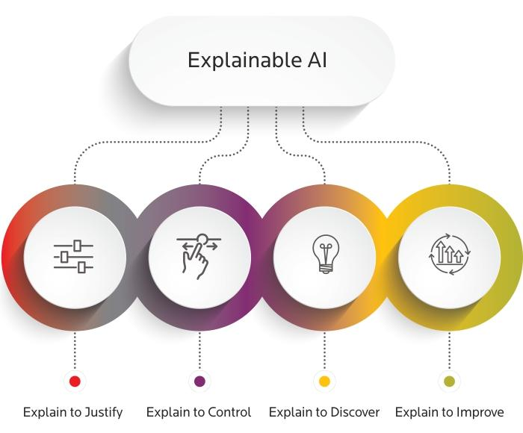
Figure(8.1) Explainabl AI

8.2:AutoML (Automated Machine Learning):

Continued growth in automated tools and platforms that simplify the end-to-end machine learning process.
Making machine learning more accessible to non-experts by automating tasks like feature engineering, model selection, and hyperparameter tuning.
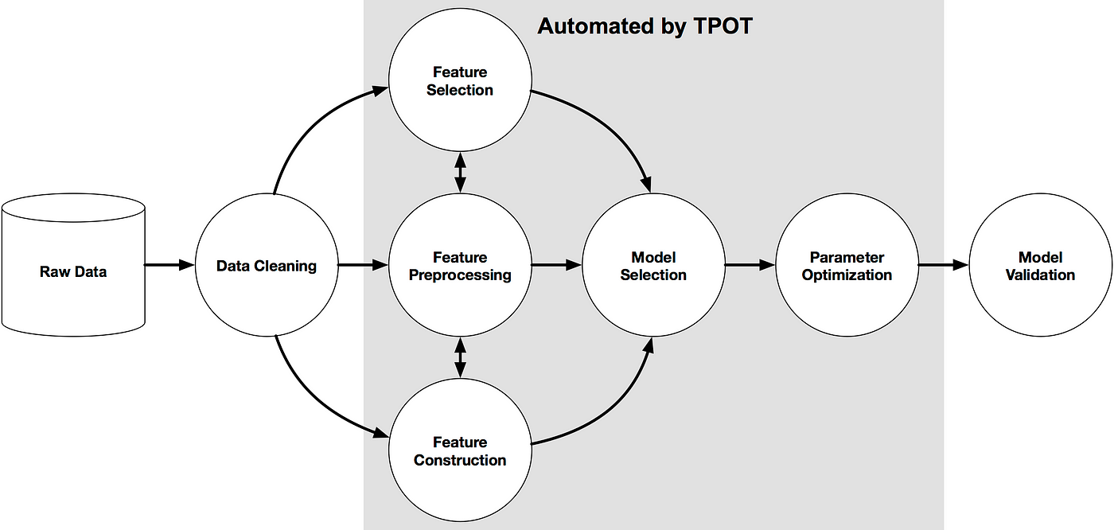
Figure(8.2) Automated Machine Learning

8.3:Time-Series Forecasting Advances:

Advancements in predictive modeling techniques tailored for time-series data.
Improved accuracy in forecasting future trends, particularly relevant in fields such as finance, supply chain management, and IoT applications.
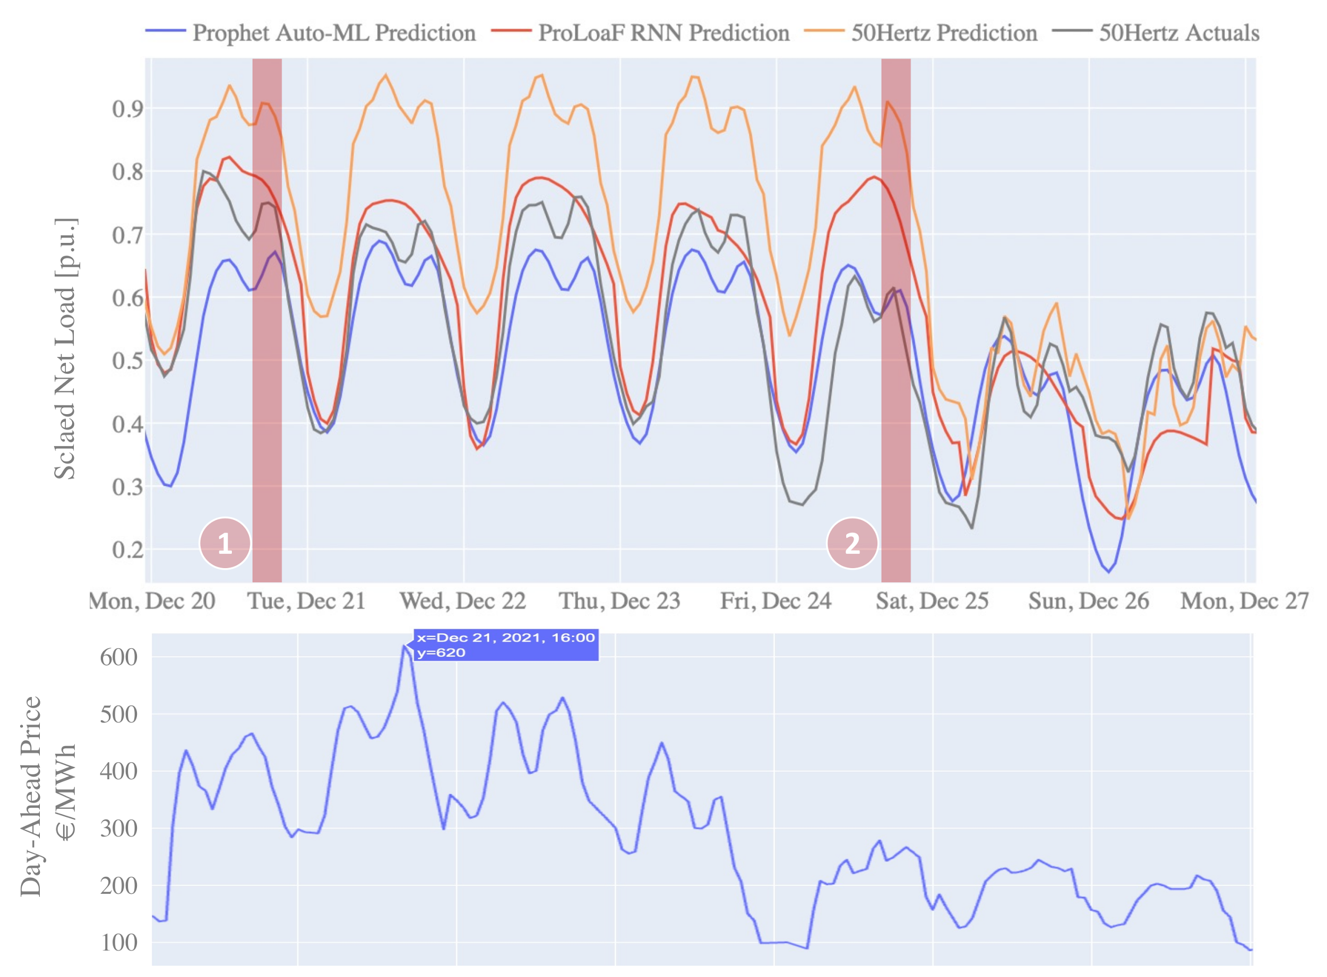
Figure(8.3) Time Series Forecasting Advances

8.4:Reinforcement Learning Integration:

Increasing adoption of reinforcement learning in predictive modeling for dynamic decision-making scenarios.
Applications in optimizing processes over time, such as resource allocation and recommendation
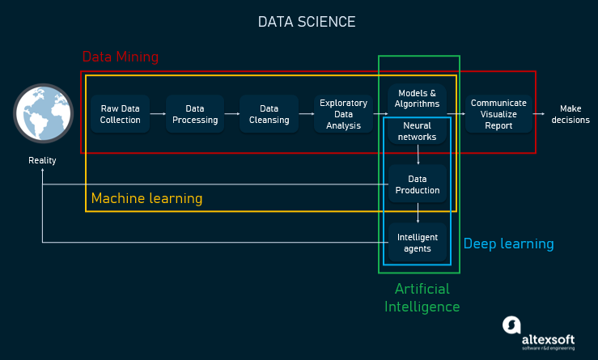
Figure(8.4) Rainforcement Learning Integration

8.5:Privacy-Preserving Predictive Modeling:

Growing concern for privacy in predictive modeling, leading to the development of techniques that protect sensitive information.
Implementation of privacy-preserving methods like federated learning and differential privacy to safeguard individual data.

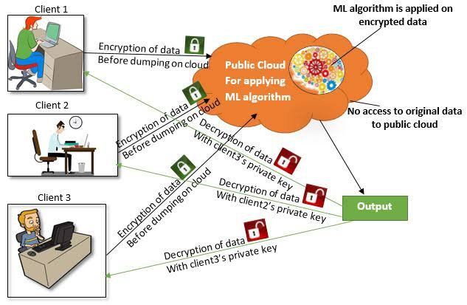
Figure (8.5) Privacy-Preserving predictive Modeling

8.6:Ensemble Learning Techniques:

Continued popularity of ensemble methods, combining predictions from multiple models for improved accuracy.
Exploration of novel ensemble techniques and their application in various domains.
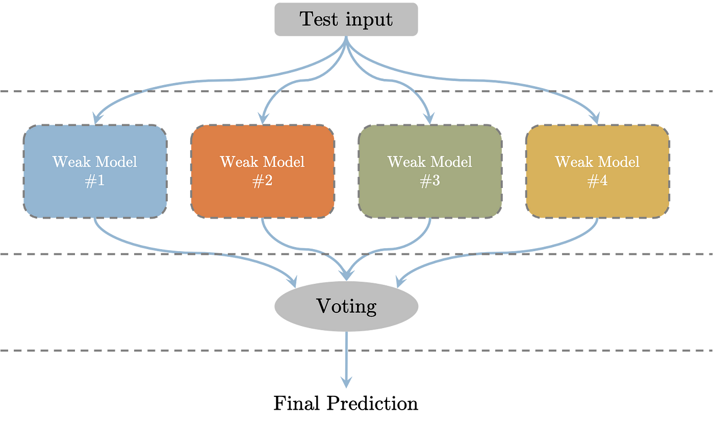
Figure (8.6)Ensemble Learning Techniques

8.7:Transfer Learning:

Application of transfer learning in predictive modeling to leverage knowledge gained from one domain and apply it to another.
Efficient use of pre-trained models for tasks with limited labeled data.

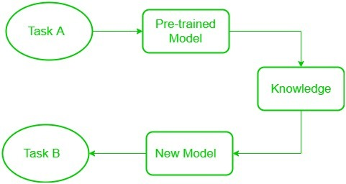
Figure (8.7) Transfer Learning

8.8:Edge Computing for Predictive Models:

Deployment of predictive models on edge devices for real-time decision-making.
Reduction of latency and dependence on centralized computing resources.
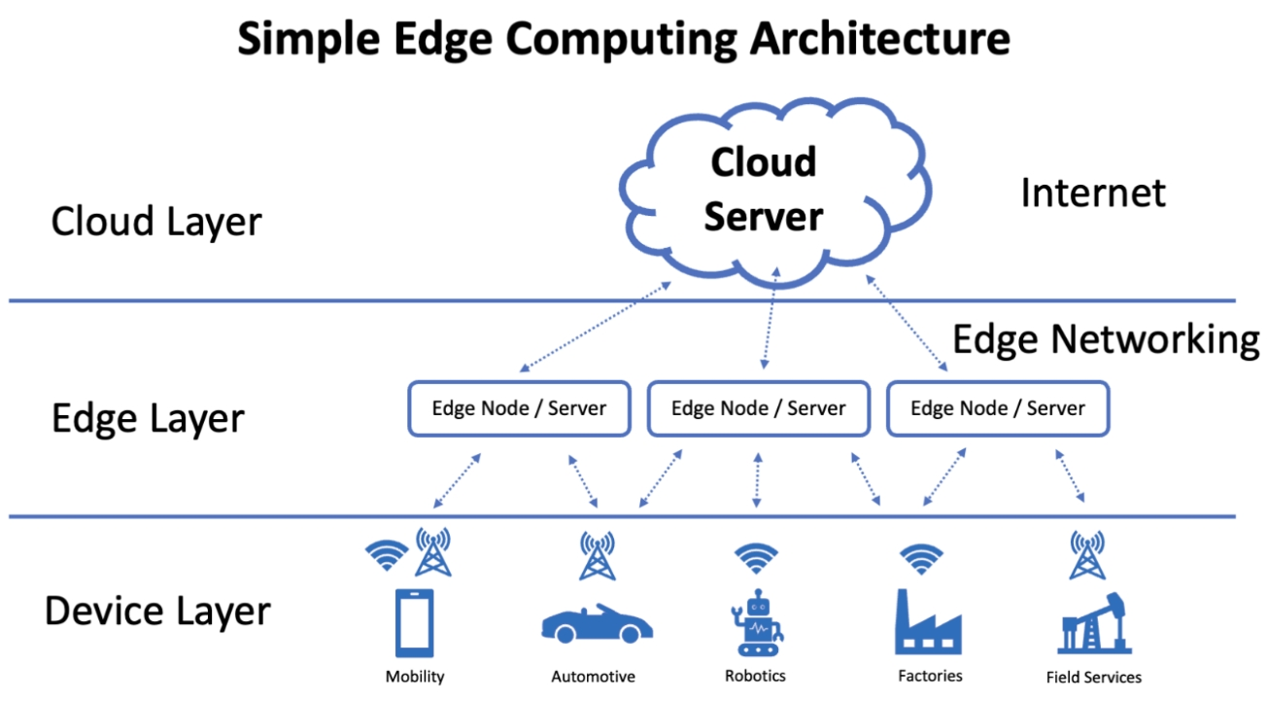
Figure(8.8) Edge Computing for Predictive Models

8.9:Ethical AI Practices:

Greater emphasis on ethical considerations in predictive modeling, addressing issues related to bias, fairness, and accountability.
Development of frameworks to ensure responsible use of predictive models.
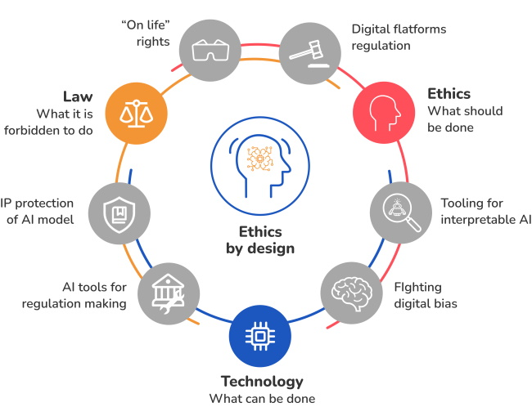
Figure(8.9) Ethical AI Practices
8.10: Conclusion:
In conclusion, predictive modeling in data science is a powerful tool that enables accurate forecasting and decision-making. By leveraging advanced algorithms and statistical techniques, it offers valuable insights into future trends and patterns. As organizations continue to embrace data-driven approaches, the importance of predictive modeling in optimizing strategies and mitigating risks becomes increasingly evident. Overall, the integration of predictive modeling enhances the efficiency and effectiveness of data science applications, contributing to informed and proactive decision-making processes.

9.DATA VISUALIZATION ADVANCED ANALYTICS

Data visualization in advanced analytics refers to the graphical representation of complex datasets to uncover patterns, trends, and insights. It goes beyond basic charts and graphs, using sophisticated visual elements and interactive tools to communicate information effectively. By transforming raw data into visually appealing and understandable formats, data visualization enhances the interpretability of analytical findings. This visual storytelling aids decision-makers in grasping key concepts, identifying outliers, and making informed choices based on a deeper understanding of the data.
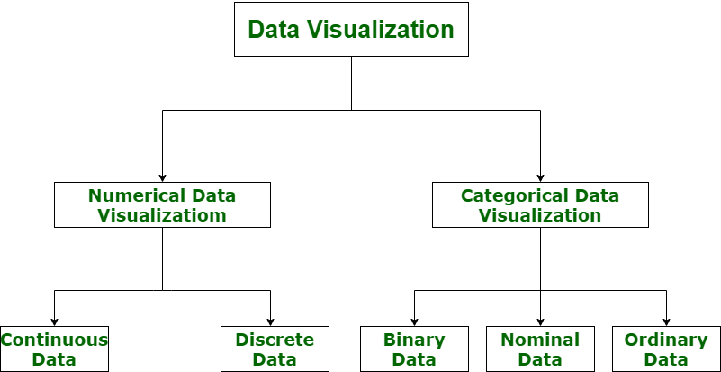
Figure(9) Data visualization advanced analytics

10.STATISTICAL DATA OF DATA SCIENCE IN TWO TO THREE YEARS

Predicting the future of statistical data in data science for the next two to three years involves some uncertainty. However, anticipated trends include further advancements in machine learning and artificial intelligence, increased emphasis on interpretability and explainability of models, and a growing focus on ethical considerations in data science practices. Additionally, the integration of more automated tools, the expansion of data sources, and improvements in data privacy and security measures are likely to shape the statistical landscape of data science in the near future.

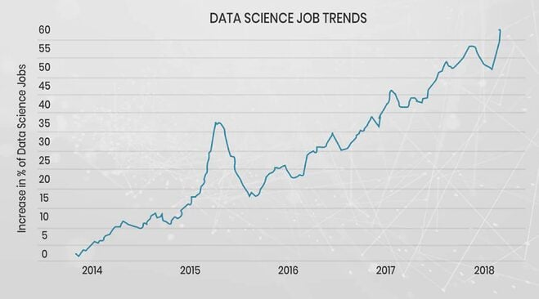

CONCLUSION:
The conclusion of a study on the evolution of data science would typically summarize key findings, trends, and insights gained from the research. It might highlight the advancements, challenges, and potential future directions in the field of data science. If you have specific points you'd like to include or discuss in the conclusion.

